3. Mini ERD - Sprint 1 Conceptual Requirement View
This corrected mini ERD contains only entities required by Sprint 1. Sprint 3 friendship, attendance, visibility, check-in and recommendation-factor entities are intentionally excluded.
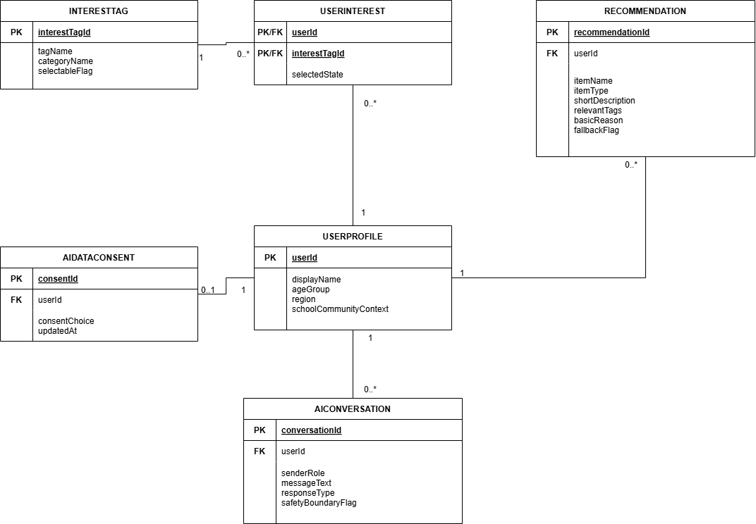
Figure 1. Corrected Sprint 1 mini ERD.
Type | Item | Fields / cardinality | Sprint 1 purpose
Entity | UserProfile | userId (PK), displayName, ageGroup, region, schoolCommunityContext | Stores the basic profile required by PBI-1.
Entity | InterestTag | interestTagId (PK), tagName, categoryName, selectableFlag | Stores selectable interest categories/tags for PBI-2.
Entity | UserInterest | userId (PK/FK), interestTagId (PK/FK), selectedState | Links users to selected interests.
Entity | AIDataConsent | consentId (PK), userId (FK), consentChoice, updatedAt | Stores whether AI features may use profile/interest data.
Entity | Recommendation | recommendationId (PK), userId (FK), itemName, itemType, shortDescription, relevantTags, basicReason, fallbackFlag | Stores basic group/event suggestions for PBI-4 and PBI-5.
Entity | AIConversation | conversationId (PK), userId (FK), senderRole, messageText, responseType, safetyBoundaryFlag | Stores AI chat interactions and safety-boundary outcomes for PBI-3.
Relationship | UserProfile -> UserInterest | 1 to many | A user may select multiple interests.
Relationship | InterestTag -> UserInterest | 1 to many | An interest tag may be selected by multiple users.
Relationship | UserProfile -> AIDataConsent | 1 to 1 | A user has one current AI-data consent preference.
Relationship | UserProfile -> Recommendation | 1 to many | A user may receive multiple suggestions.
Relationship | UserProfile -> AIConversation | 1 to many | A user may have multiple AI chat interactions.

